**IOT LAB**

**Program No - 8**

**Program Title – DISTANCE DETECTOR**

**Aim – Design a system to measure the distance between objects.**

**Hardware Required -**

* Arduino Board
* Ultrasonic distance sensor

**Circuit Diagram –**

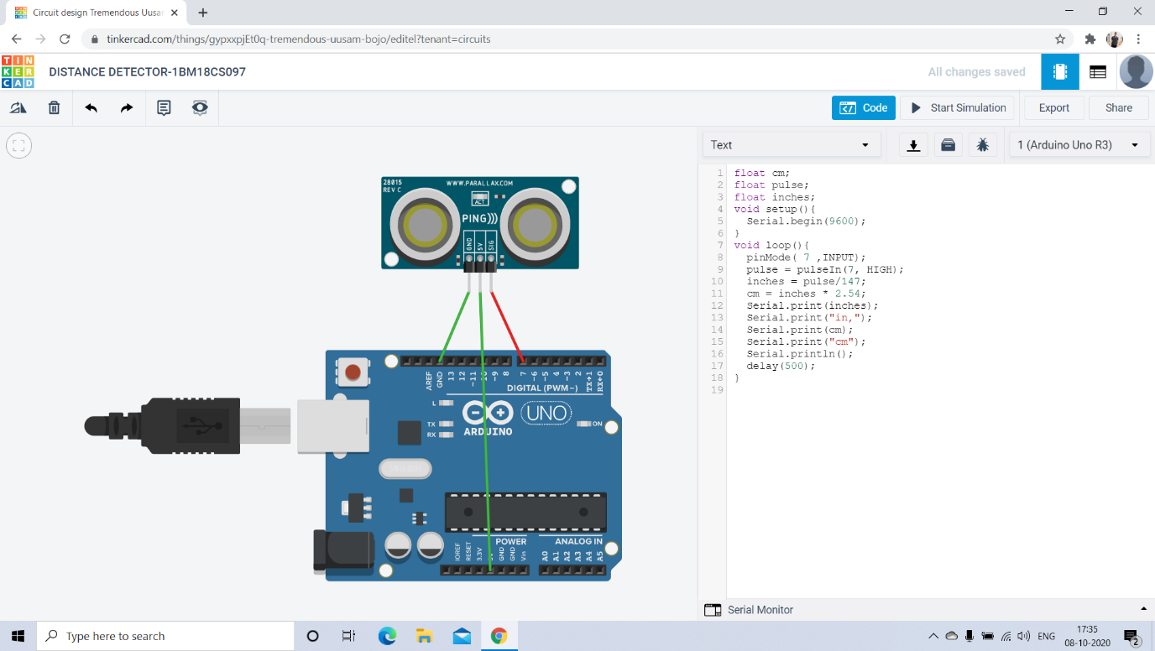

**Code:**

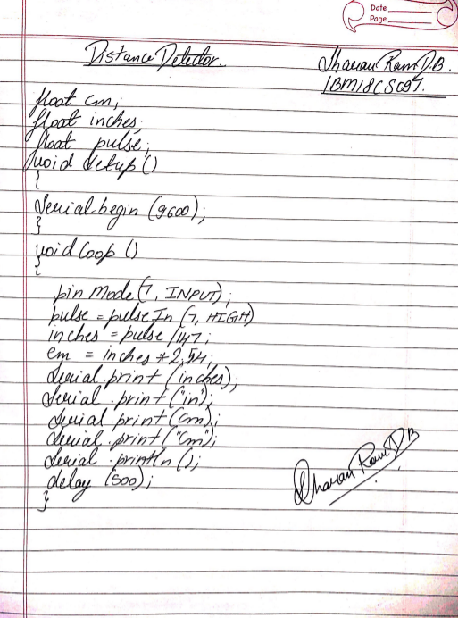

**Observation /Output –**

**The distance will be displayed in inches and centimetres as the object moves.**